# RAP-07-List Report and Object Page-Enhance UI Annotations:

<https://youtu.be/66iRYn5fZa0?list=PLqz8SLrkjv2iwPtPRJ4V6zJRfgNrgZKlQ>

## Without UI annotations- UI- will seems to like this:

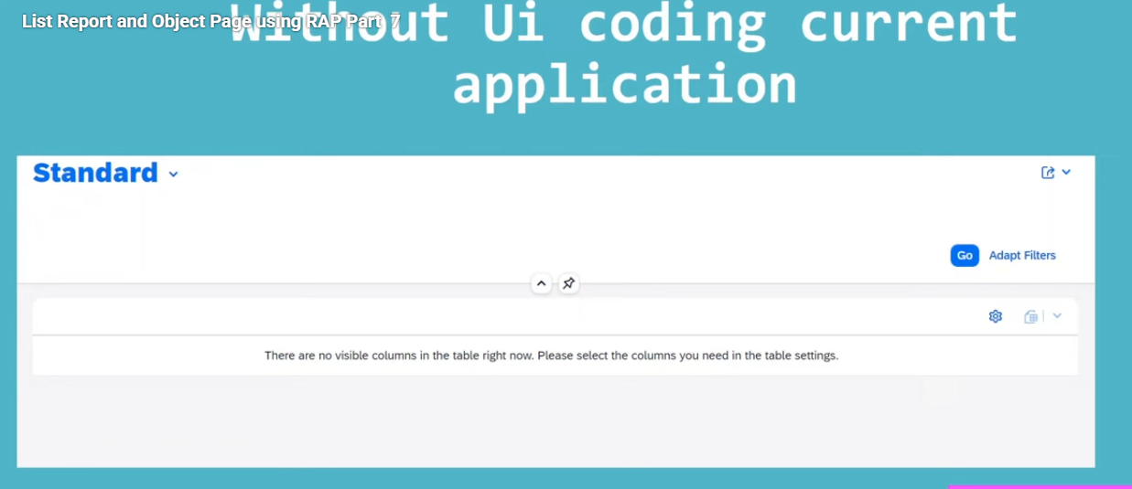

## Lets Discuss with UI annotations:

UI annotations used for how user interface looks like to the user.

How many order of the fields?

How many selection criteria are there?

Currently we are using the UI annotations for FIORi elements list page and Fiori applications to create the Fiori apps.

UI annotations, start with @UI.

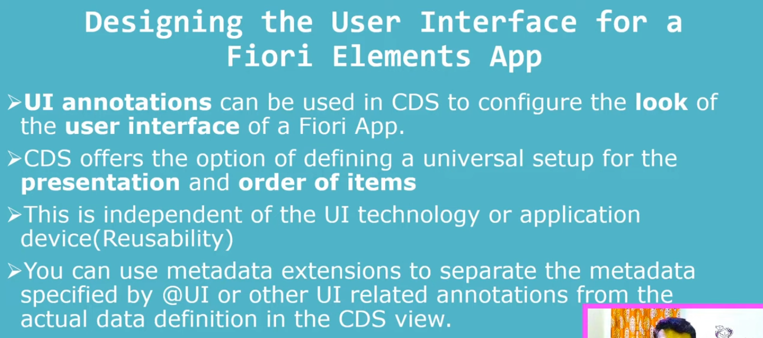

## List report:

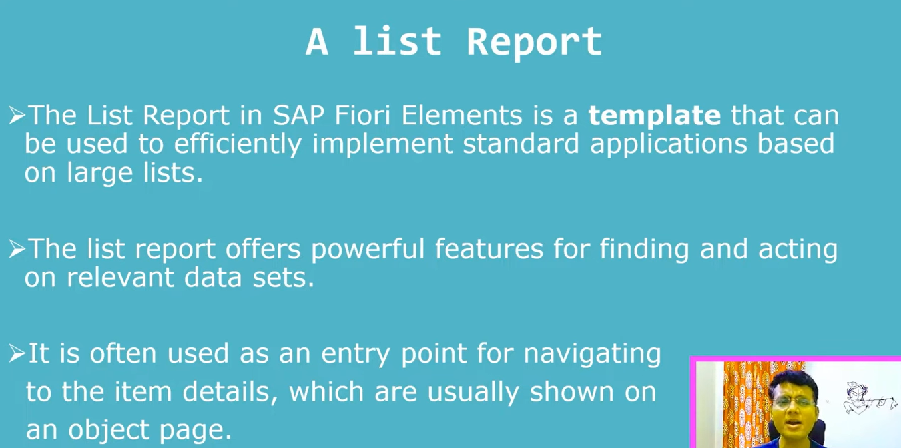

* List report like classical alv report.
* Templates:
  + List report
  + Object page – seems to like tabs in module pool
  + Analytical list page
  + Overview page .
  + Work list element page

Above templates we can create using annotations.

## Features:

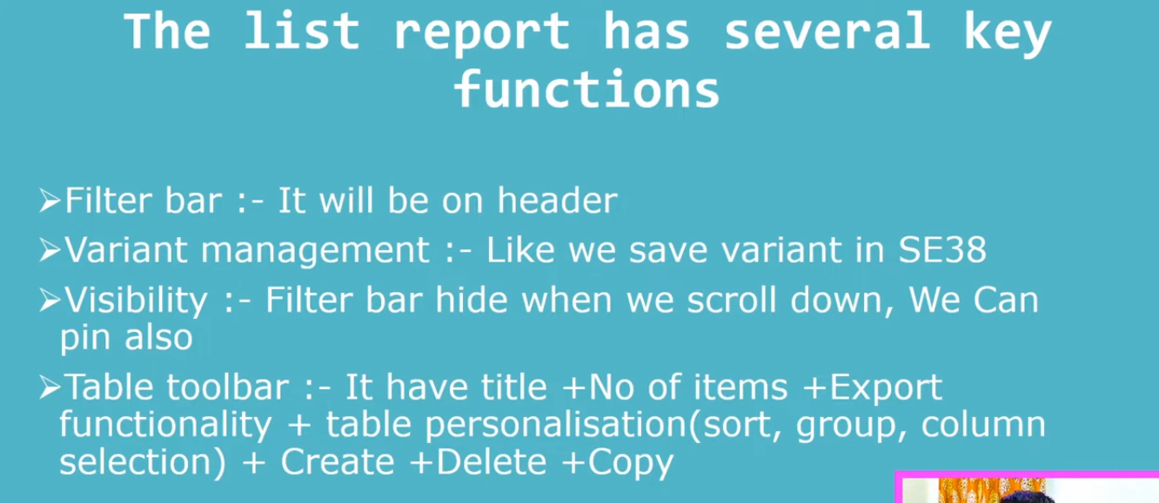

## Development-2

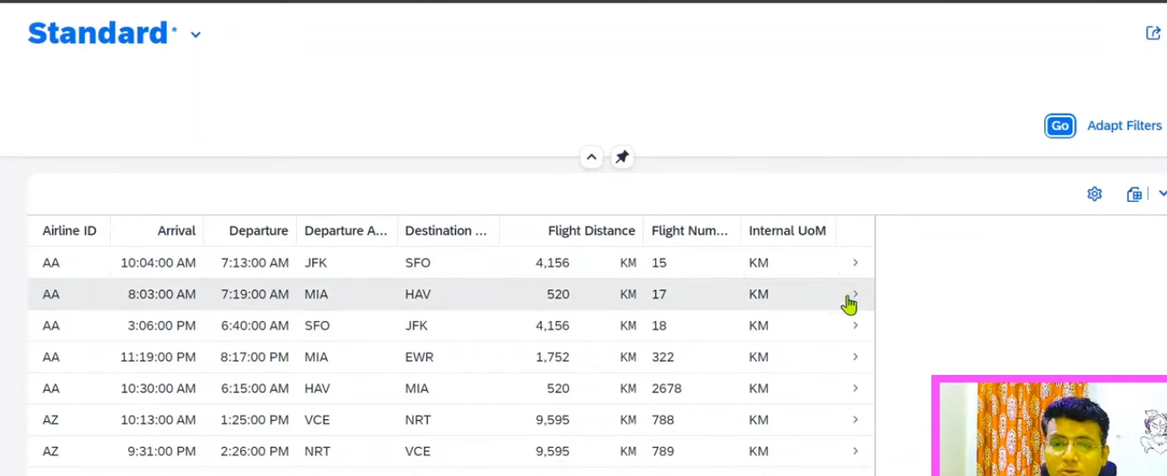

1. List report – Lables should be display by default. -when I click on preview.
2. Take care about order of the fields, sequence of fields to display.
3. Flight Distance and UOM fields have the UOM, this is not required.

### Separate the ui elements add it in metadata extension file.

1. Right click on data model- (ZI_CONNECTION_TECHNOMANIAC) 🡪 select New metadata extension file.

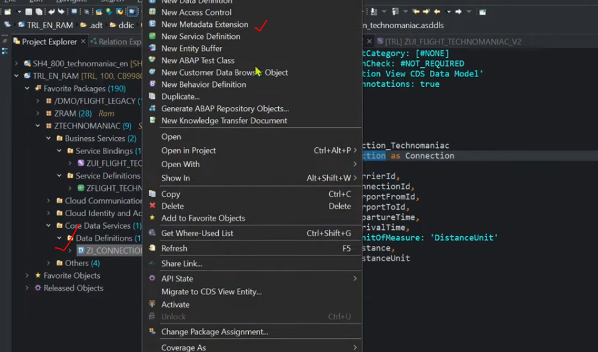

Here for our understanding purpose, we can use it as interface view as a consumption view itself.

So here interface view only we can create the UI annotations also.

Interface view: ZI_CONNECTION_TECHNOMANIAC

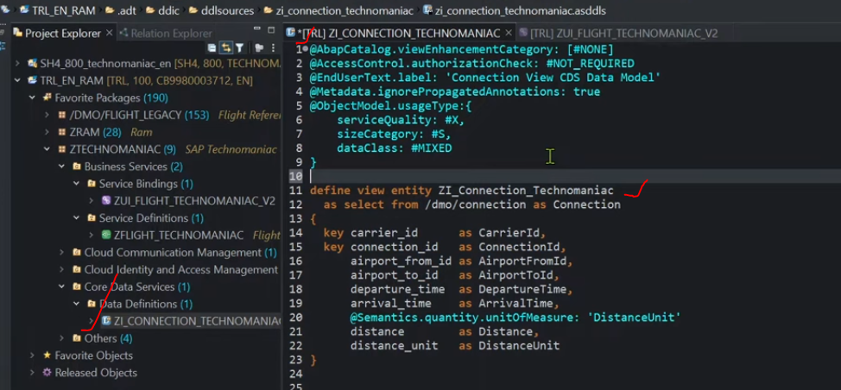

Ui annotation start with -@UI.

### @UI.headerInfo- for header level only.

* @UI.headerInfo for report list page.
* This annotation we can use it in entity level, means on top of the entity.
* 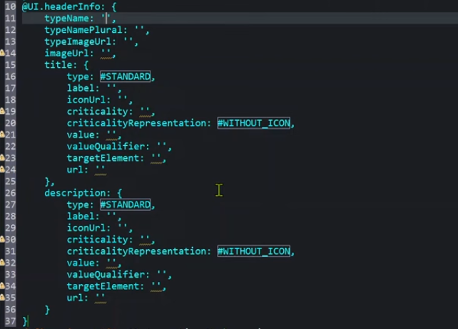
* @UI.headerInfo.typeName: ‘ ‘ – used to display at the time of single record.
* @UI.headerInfo.typeNamePlural:’ ‘ 🡪 used to display the header for multiple line items.

Or

* @UI.headerInfo: { typeName : ‘Connection‘, typeNamePlural: ‘Connections‘ }

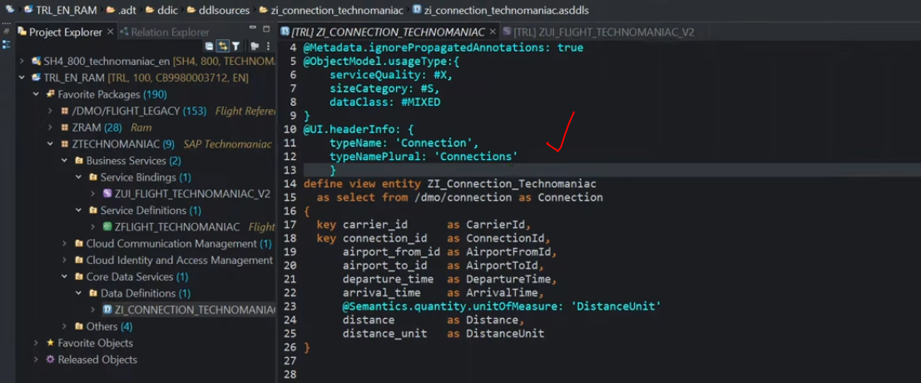

Activate it.

Output:

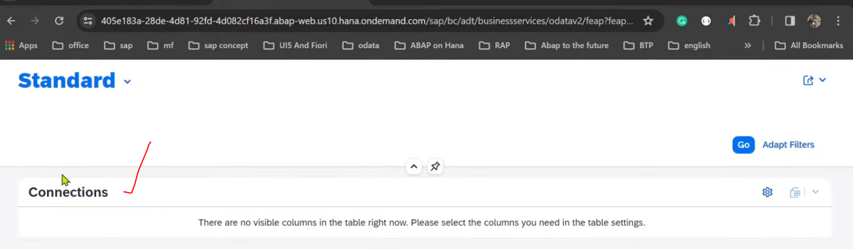

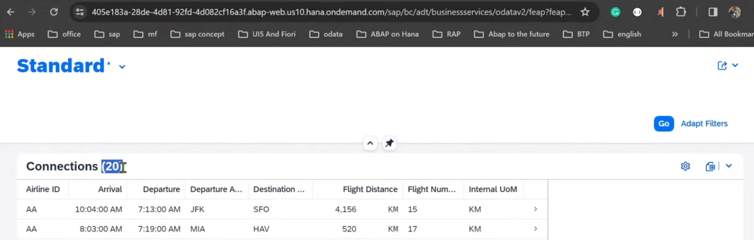

***By default system will display number of records also, when we are using ‘typeNamePlural’ – Connections(20)***

### @UI.lineItem:[{ }]- for line items- field catalog

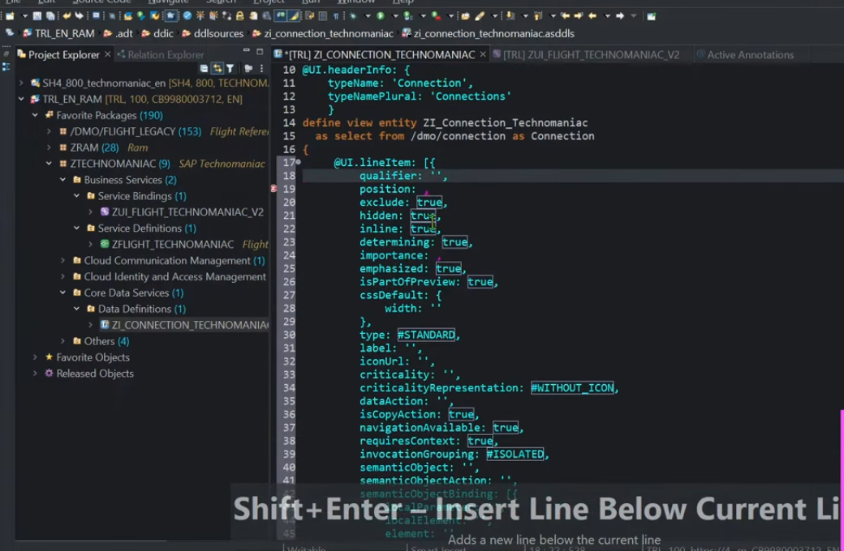

Properties:

#### Position :

* 1. which position you want to display the column.
  2. It is the numeric property
  3. It should be give the sequence number then system display sequencely.

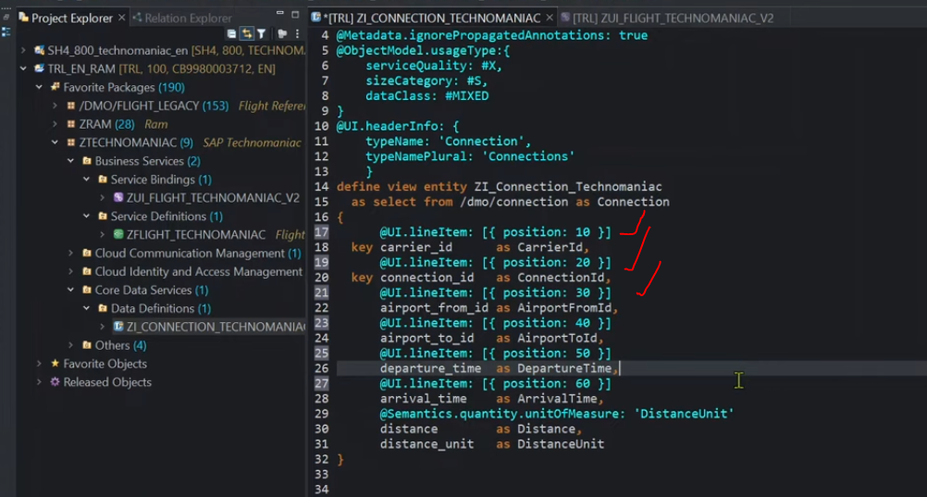

Save and activate.

Check it in output.

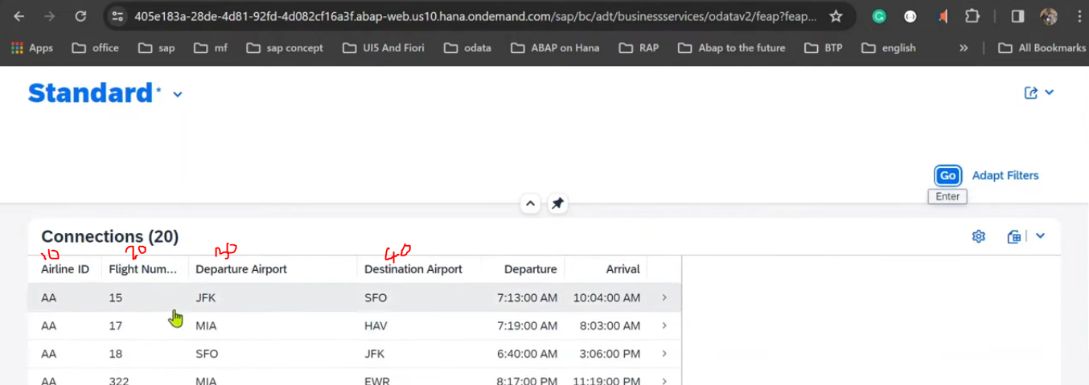

* Here headings are coming from data element only, but it is not visible in data model or another place, if you want to see all the annotations above report.
  + Right click on data model🡪Openwith 🡪@Active annotations

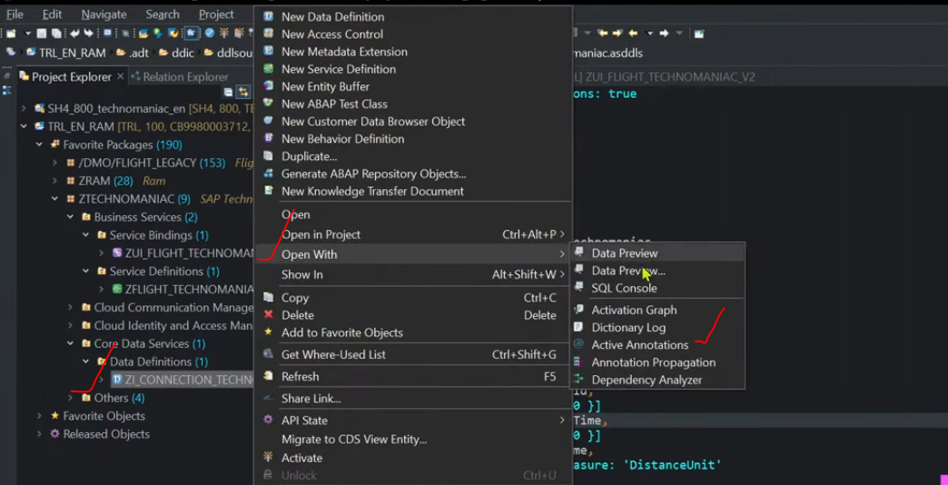

* + It will display all the annotations are used for the specific list report page.

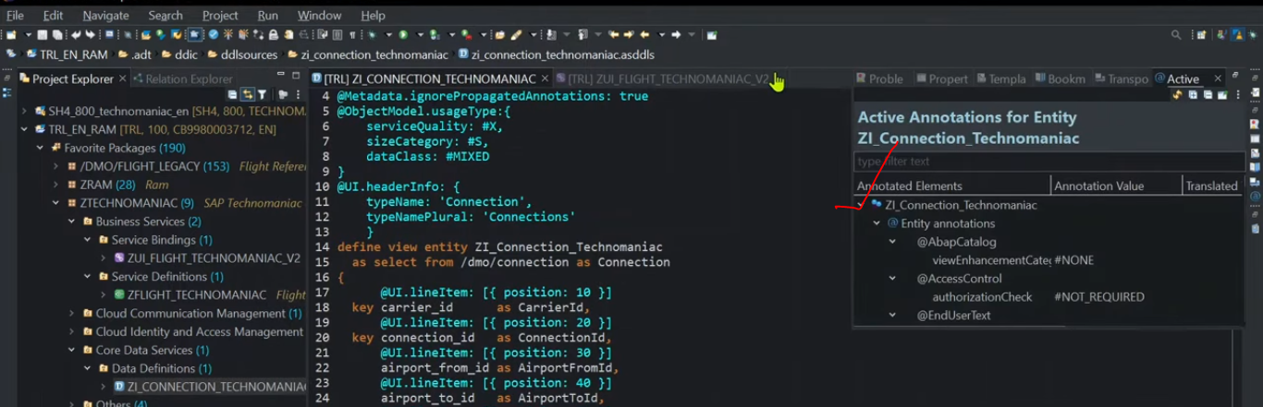

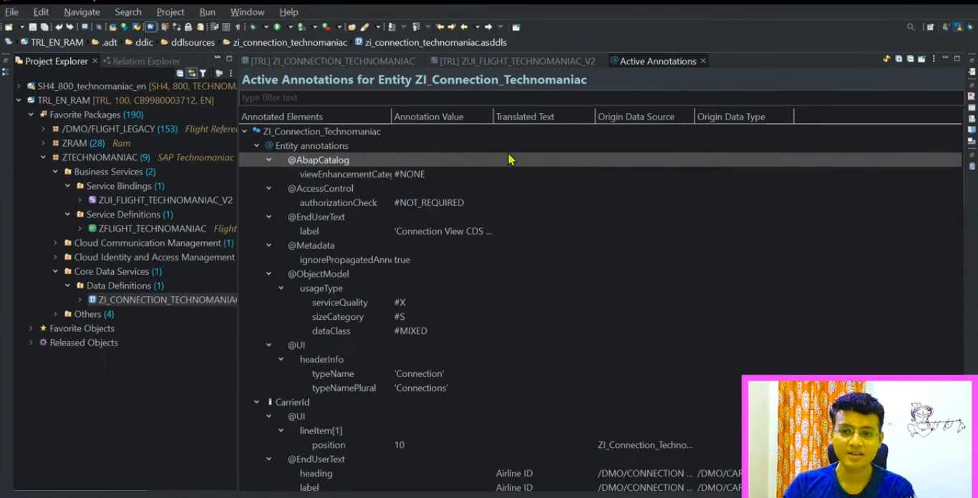

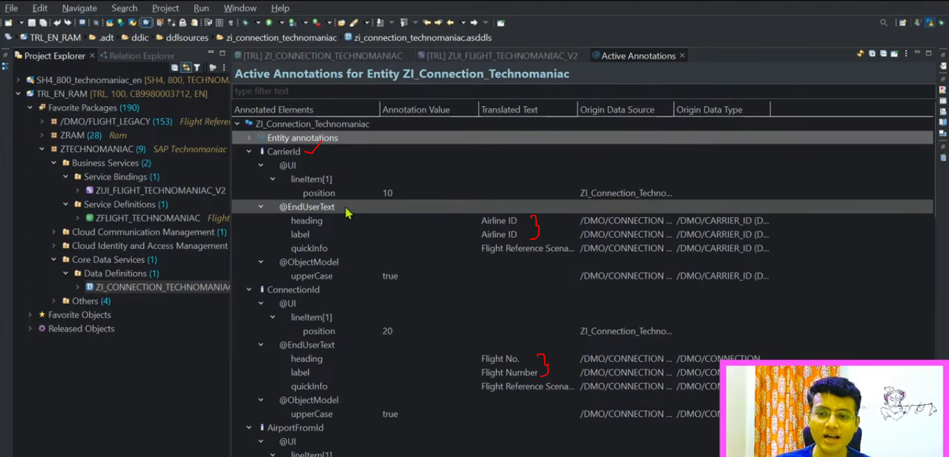

#### Changing the position numbers and testing.

Order changed.

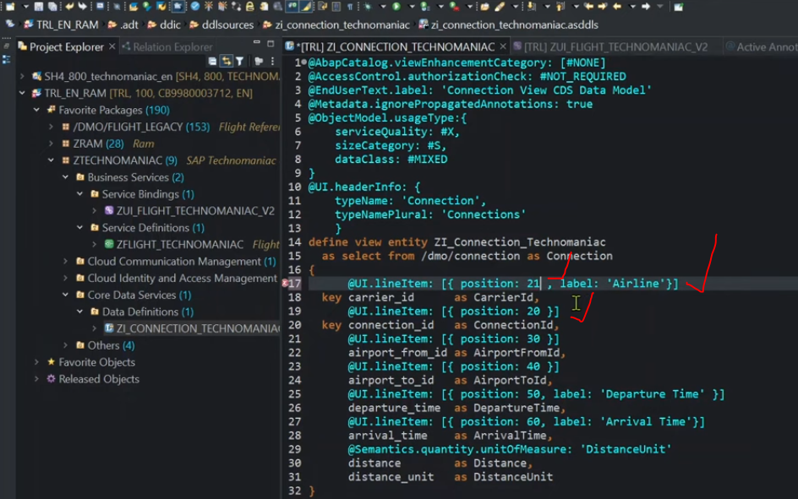

Output- also changed

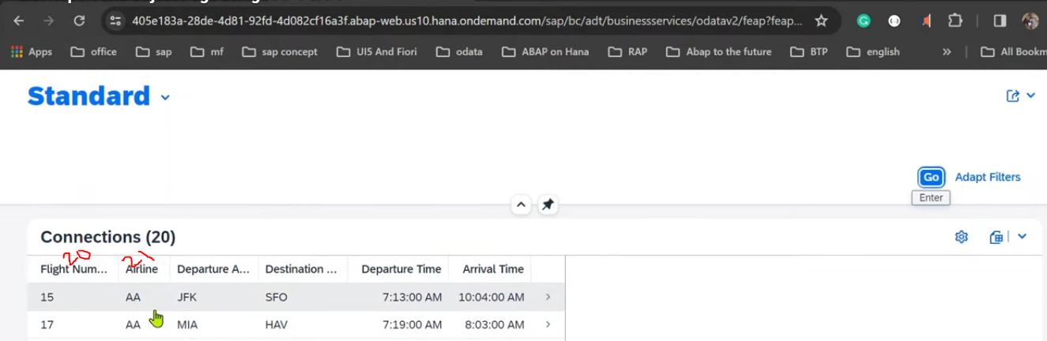

Short cut : shift + enter it will disply entire text.

#### Why we have taken postion- 10, 20, 30?

* Right now this is the initial report, so we have given the space to add more fields in between the 10 and 20 also in enhancing the report.
* We can use the decimals also @position property like position: ’20.1’ , position: 20

### @UI.lineItem:[{quickInfo: ‘ ‘ }]

@UI.lineItem:[{quickInfo:’Flight reference scenario: Carrier ID}]

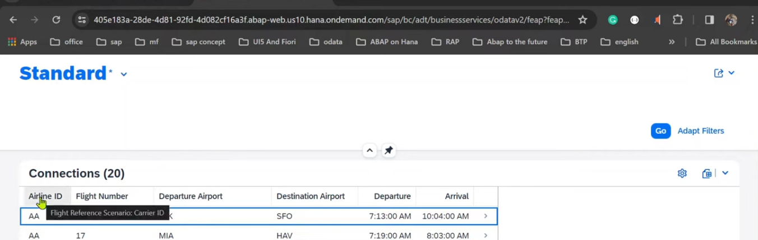

### @UI.lineItem:[{label:’ ‘}].-Change the label/Heading:

@UI.lineItem:[{label:’Airline’}]

Key carrier_id as CarrierId

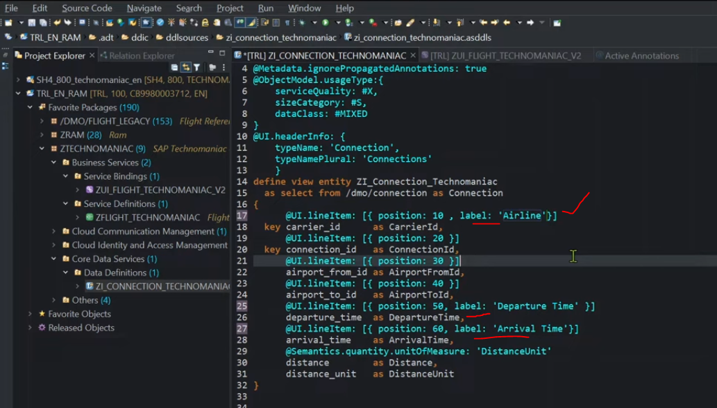

Save and activate

Output:

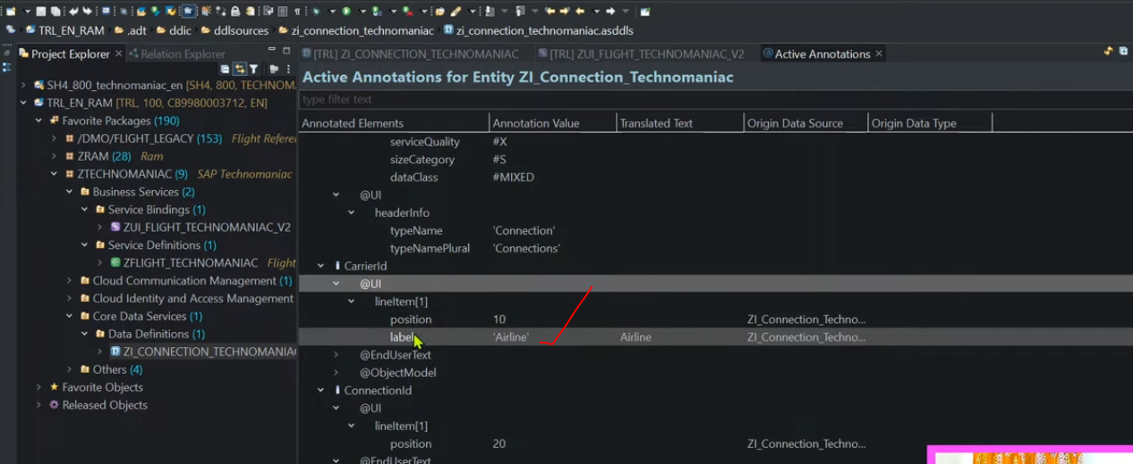

@Annotations level- preceding order –

@UI-

1. Line Item
2. End User Text
3. Object Model

First check in line item level if not available check it in end user text, here is also not available then it goes to the Object Model.

Output:

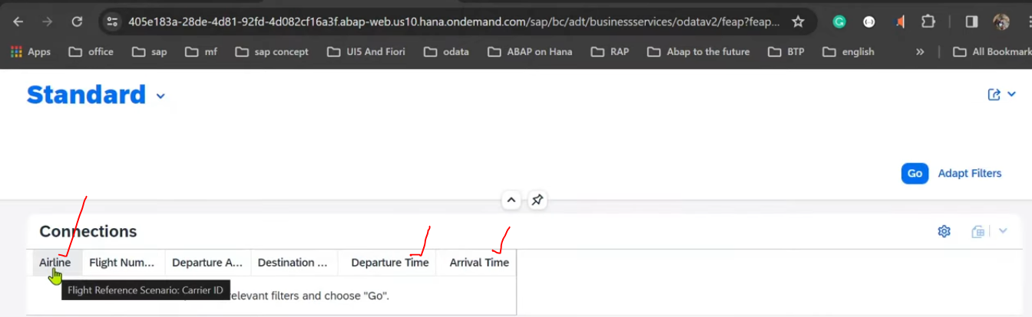

### Selection screen like the alv list

<https://youtu.be/66iRYn5fZa0?list=PLqz8SLrkjv2iwPtPRJ4V6zJRfgNrgZKlQ&t=1247>